class 7 notes

Monetizing Your Weblog

(Blogging is a superb way to generate traffic and interest in your products and services, but it turns out that your blog itself can generate you money too, through advertising and more. We'll talk about the options and you'll learn my secrets to producing thousands of dollars each month in Google AdSense revenue)

Monetizing Your Weblog

First off, are you sure you want to do this?
The upside is that you can generate reevnue, but if you're putting in the work to get someone to your site, are you going to be happy when you make $0.17 and send them to a potential competitor rather than selling them your own product or service?

Pay Per Click
There are a number of text ad programs available but the most popular and highly visible is Google's AdSense program. If you haven't signed up, click on the button below and join up:
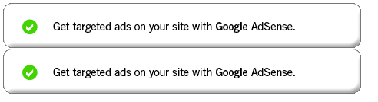
Once you've signed up you can pick one of a variety of different ad layouts, choose between text and graphical ads, and even place up to three ad "units" on your page. Here's a link to some sample ads: Ad Formats. I also suggest that you use channels if you have more than one site so you can differentiate between sites when analyzing traffic and revenue.
You can also fine-tune the color scheme of the ad which is a critical step. Don't use the default color scheme! It's amazing to me how many sites have their advert distinct from their content, making it really easy for people to breeze over the ad without processing it or clicking on it. The net result? No clicks = no revenue.
I have found experimentally that removing all borders and trying to have your ad match your site's color scheme as much as opssible is a good strategy. Further, put your ad where people can't help seeing it. Again, it's amazing how many sites have their ads tucked in a far corner of the design then complain that they don't ever get any clicks. Instead, consider placing the ad front and center. See: My iPod Won't Turn Off! and notice how the ads are impossible to miss and how the color scheme of the entire site helps encourage people to click on the ad.
So let's have a quick look at an AdSense report for last month:
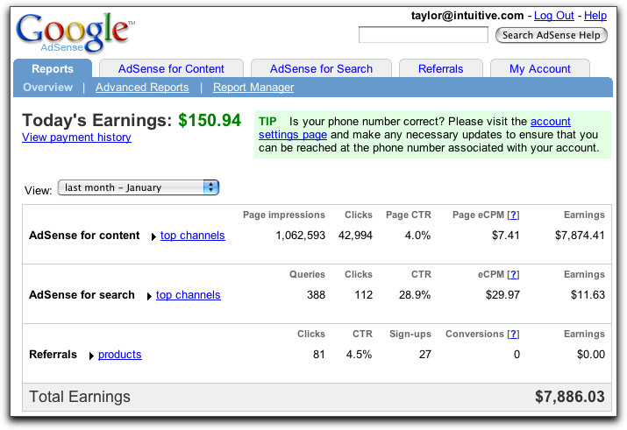
You can see that I've earned about $150 so far today (I earn most of my money in the evenings, interestingly) and that when I view last month's earnings (note the popup!) I cleared $7886. A good month!
Since I organize things by channel across my sites, and further break down into channels for different ad layouts, I can click on 'top channels' for last month and find out that:
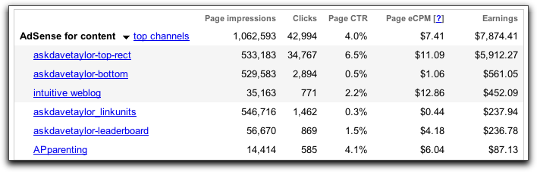
AskDaveTaylor did the best, with the top-rect (between the Q and the A on the individual pages) accounting for the vast majority of my revenue, just a bit over $5900. Notice most importantly the CTR, or clickthru rate. That's the magic number: you could have very low clicks and a high CTR and still make a lot of money with AdSense...
There are other ad networks that offer similar contextual ads to Google, notably including Yahoo's YPN service (formerly Overture) and Microsoft has been hinting at releasing an "AdSense killer" for months. Some folk have great results with YPN, but as for me, AdSense is working just fine...

Textual Links Alone
Even after the debunking of the importance of PageRank, there are still companies that will pay a lot of money to get plugged in with high PR sites, and I leverage that with AdZaar. Notice the very, very bottom of my pages:

AdZaar pays me just a bit over $2000/month to have those tiny text links on the bottom of all pages on all my Web sites. You'll need at laeast a PR5 to sign up, but if you ahve a bunch of PR6 sites - or higher - it's a really easy way to supplement your income, even if you don't want anything as overt as AdSense.
Please note: If you're interested in signing up for AdZaar, please send me an email and I'll refer you. I'll earn a small commission and you'll get a priority response for your application.
Again, there are other alternative ad networks out there, including Text-Link-Ads.com, but I don't have any experience with them (as of yet!)

Affiliate Programs
Affiliate sales are huge and can be an important revenue stream for you selling your own goods or services through affiliated sales people or for you selling other people's stuff with special links. Whenever I mention a book or other product, I'll try to link it to an affiliate site. For example, go back to that iPod blog entry and click on the picture of the iPod nano...
I don't make a ton of money on my Amazon Affiliates program, but if I'm going to talk about a book anyway, why not make a few dollars off the link? Here's a typical product sales report:
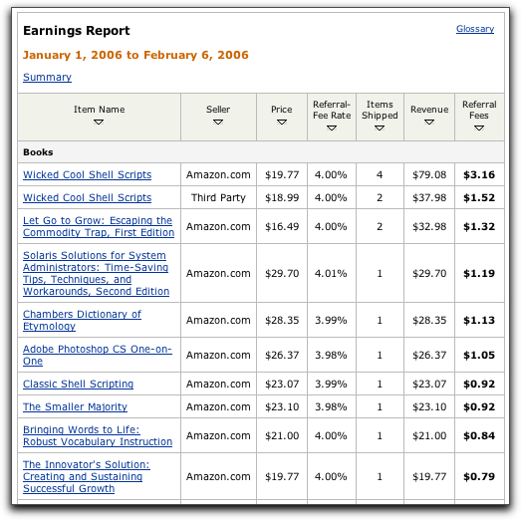
No great sales, but a nickle here, a dime there, adds up to another few hundred dollars down the road...
There are lots of different affiliate programs if you want to go down this road and a good place to start is at the popular site Commission Junction.

Ads in RSS Fees
Google lets you drop AdSense ads into your RSS feed of your weblog (they call it "AdSense for Feeds", logically enough) but I don't know of anyone who is doing well with it and in fact I have it on one of my feeds -- for Real Life Debt Blog, and I have (shhh) clicked on an ad and never had it register. Not good.
An alternative I just signed up for yesterday is Pheedo and in the 24 hours it's been running I've earned a whopping $8.34. Not a staggering number, but then again, that's still roughly $250/month in additional revenue. What's nice is that Pheedo also has some very nice statistics it shows in your reports:
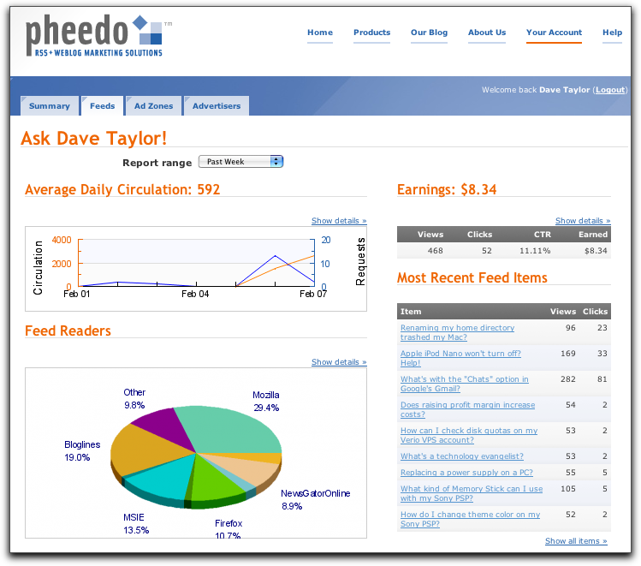

Other ways to monetize your blog?
There are other ways you can generate revenue frmo your weblog, including sponsorships, product placements, etc., but those typically require that you already have a relationship with the vendor. It's doable, but you need to ask if that's how you want to spend your energy or not...

